Name ________________________ __________________________________

1A Human Biological Science
Test 1 – Cells and Body Systems

- 36 multiple choice questions worth 36 marks
- 5 short answer questions worth 24 marks
- Time allowed: 1 hour
- This test is worth 15% of your semester grade

Part A – Multiple choice
Select the best answer to each question with a circle

1. The part of the cell that selects which substances enter or leave the cell is the
a. cell membrane
b. mitochondria
c. vessicles
d. Golgi body
2. The cytoplasm is the material in which the contents of the cell are suspended. It is made of 75% to 90%
a. glucose
b. water
c. protein
d. fat
3. Inside the nucleus is the DNA. The DNA
a. contains information that determines the types of proteins a cell can make.
b. is converted to energy for the cell in the presence of oxygen
c. absorbs fat in times of famine so the cell does not starve
d. directs nucleic acids and amino acids toward the ribosomes
4. This diagram shows
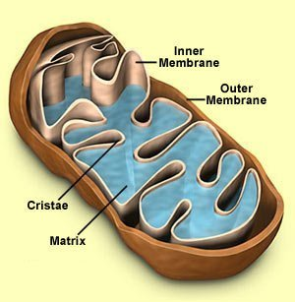
a. the nucleus
b. endoplasmic reticulum
c. flagella
d. a mitochondrion

5. Which of these is not a way material can move into a cell?
a. diffusion
b. osmosis
c. haemoglobin
d. endocytosis
6. Why has the concentration of particles become the same on both sides?

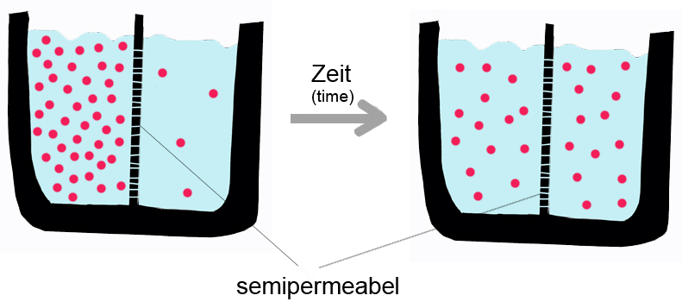
a. the semipermeable membrane has forced the particles to the right
b. the particles would have all moved but the time has run out for the experiment
c. particles tend to move from areas of high concentration to areas of low concentration
d. this diagram is in German and I don't understand it

7. This is the view under a microscope. Estimate the diameter of the field of view
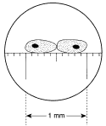
a. 0.5mm
b. 1mm
c. 1.2mm
d. 1.5mm

8. A microscope has an ocular lens with a magnification of x10. If a student uses an objective lens of magnification of x10, what is the total magnification?
a. x10
b. x20
c. x40
d. x100
9. Cellular respiration is
a. the joining of amino acids to make protein
b. responding to an external stimulus
c. breaking down glucose to release energy
d. pumping blood around the body

10. If a sultana is put into a glass of water, it swells up. This is an example of
a. diffusion
b. active transport
c. plasmolysis
d. osmosis
11. If a cube has sides of 2cm, what is the cell’s surface area?
a. 2cm²
b. 8 cm²
c. 24 cm²
d. none of the above
12. What chemical digestion happens in the mouth?
a. chewing
b. saliva
c. swallowing
d. tasting
13. The rhythmic contraction of muscles in the oesophagus causing swallowing is
called
a. epiglottis
b. peristalsis
c. pharynx
d. duodenum
14. Which teeth are involved with crushing and grinding food?
a. incisors
b. canines
c. molars
d. villi
15. The enzyme in the stomach that breaks down protein is
a. pepsin
b. amylase
c. lipase
d. nuclease

16. Diarrhoea is
a. frequent defaecation of watery faeces
b. inflammation of the appendix
c. extremely slow movement of material through the colon
d. and automatic response that pushes the contents of the stomach out
through the mouth

17. Air passes through the respiratory system in the order
a. nasal cavity > pharynx > trachea > bronchi
b. nasal cavity > bronchi > alveoli > pharynx
c. nasal cavity > bronchi > trachea > alveoli
d. nasal cavity > trachea > alveoli > bronchioles
18. When we breathe in
a. The diaphragm relaxes and bulges up into the chest cavity
b. The volume of the chest cavity is reduced
c. Air pressure in the lungs is lower than air pressure outside
d. The intercostal muscles relax and the ribs move downwards
19. Which gas diffuses from the blood into the alveoli when we breathe out?
a. carbon dioxide
b. nitrogen
c. oxygen
d. chlorine
20. Which disorder of the lungs is caused by an allergic reaction to particles that
are foreign to the body?

a. lung cancer
b. emphysema
c. pneumonia
d. asthma
21. The kidneys are located
a. above the heart
b. below the diaphragm
c. in the legs
d. behind the bladder
22. Urine flows
a. from the pelvis of the kidneys to the bladder
b. from the kidneys to the anus
c. from the bladder to the kidney
d. from the cortex of the kidneys to the appendix
23. Nephrons are
a. a cellulose tube used in dialysis
b. the concentrated blood filtrate inside the kidney
c. tiny tubes that filter water and dissolved substances from the blood
d. two large tubes that take urine to the bladder

24. The right side of the heart pumps blood to the
a. head
b. kidneys
c. lungs
d. legs
25. The purpose of the atrioventricular valves is
a. to prevent backflow of the blood into the atria
b. make lubb-dupp sounds
c. pump blood into the ventricles
d. act as parachutes in the heart
26. Arteries carry blood
a. to the lungs
b. away from the heart
c. to the heart
d. away from the lungs
27. Which of these is not a sense organ?
a. eye
b. ear
c. tongue
d. tooth
28. The retina
a. is sensitive to light
b. contains rods and cones
c. lines the rear part of the inside of the eyeball
d. all of the above
29. The iris contains muscles that cause the pupil to dilate (open wider). Why does
the pupil dilate?

a. to protect the retina from bright light
b. to show less of the coloured part of the eye
c. to let more light into the eye in dim conditions
d. to see a wider image

30. In which order is sound passed through the ear?
a. pinna > ear canal > ear drum > cochlea
b. pinna > ear drum > ear canal > hammer
c. pinna > hammer > anvil > ear drum
d. pinna > cochlea > ear drum > stirrup
31. Apart from hearing, what else do the ears sense?
a. keeping your glasses on
b. awareness of angry animals
c. balance
d. smell
32. Which of these is not a cause of deafness?
a. fusing together of the small bones of the middle ear
b. blockage of the ear canal by wax
c. build up of fluid in the middle ear
d. bacterial or fungal infection of the pinna
33. Bruising is

- caused by blood leaking into surrounding tissues
- the formation of a clot in or near the heart
- when blood flow to the heart is stopped
- when the number of red blood cells is below normal

34. Which of these substances are not absorbed in the small intestine?

a. glucose
b. amino acids
c. fatty acids
d. insoluble fibre

35. The human body is organised in the order

- cell, organ, tissue, system
- tissue, cell, system, organ
- system, organ, cell, tissue
- cell, tissue, organ, system

36. Which type of tissue is shown in this diagram?
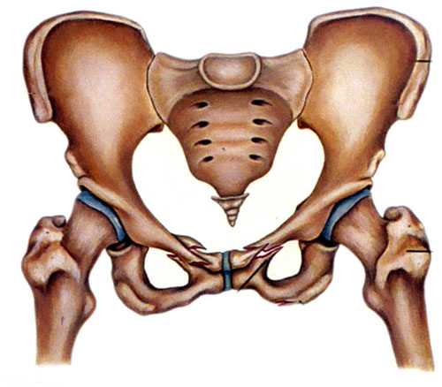
a. muscular tissue
b. nervous tissue
c. connective tissue
d. epithelial tissue

End of Part A
Part B – Short Answer
Write your answers in the spaces provided

1. a. Label the parts A – E of the cell

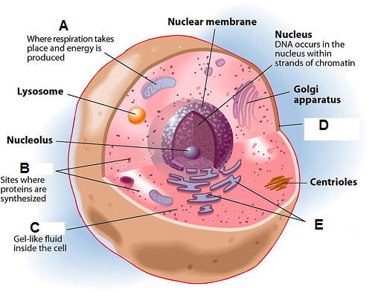

A _________________________________________

B _________________________________________

C _________________________________________

D _________________________________________

E _________________________________________ (5 marks)

b. What are vesicles? Describe two ways that vesicles can form in the cell.

_________________________________________________________

_________________________________________________________

_________________________________________________________

_________________________________________________________

___________________________________________ (3 marks)
2. a. In what part of the ear are the receptors for hearing?

____________________________________________ (1 marks)

- Explain how the vibrations of sound waves are passed from the ear drum to the part of the ear that contains the receptors.

_________________________________________________________

_________________________________________________________

_________________________________________________________

_________________________________________________________

_________________________________________________________

____________________________________________ (4 marks)

3. Explain how is the eye able to focus light from far objects and near
objects onto the retina.
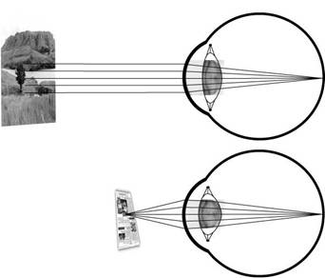

_________________________________________________________

_________________________________________________________

_________________________________________________________

_________________________________________________________

_________________________________________________________

___________________________________________ (3 marks)
4. Sketch one half of a dissected kidney. Label the renal artery, the renal vein, the ureter and the renal pelvis.

(5 marks)

5. Explain the changes in the intercostal muscles and diaphragm cause us to breathe in. If you wish, you may a diagram to help explain.

_________________________________________________________

_________________________________________________________

_________________________________________________________

_________________________________________________________

_________________________________________________________

_________________________________________________________

_________________________________________________________

__________________________________________________ (3 marks)

End of Part B
End of Test

